**Different forms of dances in India**

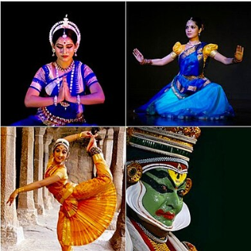**Dance in India** comprises numerous styles of dances, generally classified as classical or folk. As with other aspects of Indian cultures, different forms of dances originated in different parts of India, developed according to the local traditions and also imbibed elements from other parts of the country.

Sangeet Natya Academy, the national academy for performing arts in India, recognizes eight traditional dances as indian classical dances, while other sources and scholars recognize more. These have roots in the Sanskrit text Natya Shastra and the religious performance arts of Hinduism.

**Origins of dance in India**

The origins of dance in India go back to ancient times. The earliest Palaeolithic and Neolithic cave paintings such as the UNESCO world heritage site at Bhimpetka rock shelters in Madhya Pradesh show dance scenes. Several sculptures found at Indus Valley Civilisation archaeological sites, now distributed between Pakistan and India, show dance figures.

The evidence of earliest dance-related texts are in Natasutras, which are mentioned in the text of Panini, the sage who wrote the classic onSanskrit grammar, and who is dated to about 500 BCE. This performance arts related sutra text is mentioned in other late Vedic texts, are as two 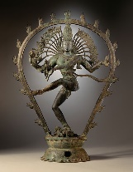scholars names Shilalin and Krishashva, credited to be pioneers in the studies of ancient drama, singing, dance and Sanskrit compositions for these arts. Richmond et al. estimate the Natasutras to have been composed around 600 BCE, whose complete manuscript has not survived into the modern age. India has a number of classical Indian dance forms, each of which can be traced to different parts of the country. Classical and folk dance forms also emerged from Indian traditions, epics and mythology.

**Classical dance**

Classical dance of India has developed a type of dance-drama that is a form of total theatre. The dancer acts out a story almost exclusively through gestures. Most of the classical dances of India enact stories from Hindu mythology. Each form represents the culture and ethos of a particular region or a group of people.

The criteria for being considered as classical is the style's adherence to the guidelines laid down in Natyashastra, which explains the Indian art of acting. The Sangeet Natak Akademi currently confers classical status on eight Indian classical dance styles:

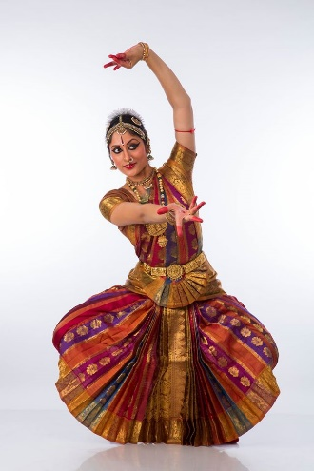

* **Bharatanatyam:** Dating back to 1000 BC, barathanatyam is a classical dance from the South Indian state of Tamil Nadu, practiced predominantly in modern times by women. The dance is usually accompanied by classical Carnatic music. Bharatnatyam is a major genre of indian classical dnace that originated in the Hindu temples of Tamil Nadu and neighboring regions. Traditionally, Bharatanatyam has been a solo dance that was performed exclusively by women, and expressed Hindu religious themes and spiritual ideas, particularly of Shaivism, but also of Vaishnavism and Shaktism.
* 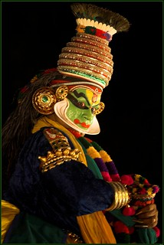**Kathakali:** It is a highly stylized classical dance-drama form, which originated from Kerala in the 17th century. This classical dance form is another "story play" genre of art, but one distinguished by its elaborately colourful make-up, costumes and face masks wearing actor-dancers, who have traditionally been all males.
* 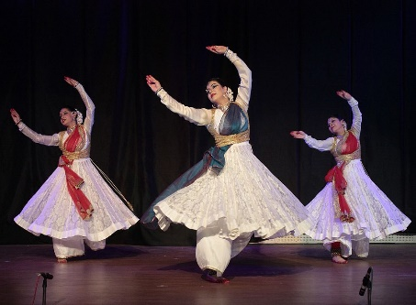**Kathak:** It is found in three distinct forms, named after the cities where the Kathak dance tradition evolved – Jaipur, Benares and Lucknow. Stylistically, the Kathak dance form emphasizes rhythmic foot movements, adorned with small bells (Ghungroo), the movement harmonized to the music, the legs and torso are generally straight, and the story is told through a developed vocabulary based on the gestures of arms and upper body movement, facial expressions, stage movements, bends and turns.
* 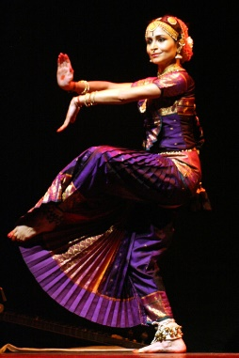**Kuchipudi:** This classical dance form is originated in a village of Krishna District in modern era Indian state of Andhra Pradesh It has roots in antiquity and developed as a religious art linked to traveling bards, temples and Kuchipudi dancers were all males, typically Brahmins, who would play the roles of men and women in the story after dressing appropriately.
* 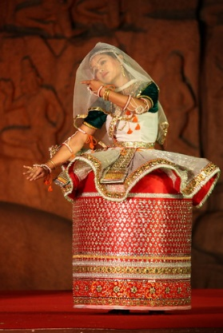**Manipuri:** Manipuri Raas Leela dance is a unique form of dance drama which has its origin in Manipur, a state in north eastern India bordering with Myanmar (Burma). It is particularly known for its Hindu Vaishnavism themes, and performances of love-inspired dance drama of Radha-Krishna called Raas Leela. The Manipuri Raas Leela dance is a team performance, with its own unique costumes notably the Kumil , aesthetics, conventions and repertoire.

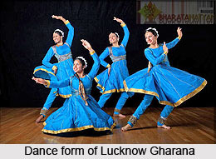Some traditions of the Indian classical dance are practiced in the whole Indian subcontinent, including Pakistan and Bangladesh, with which India shares several other cultural traits. Indian mythologies play a significant part in dance forms of countries in Southeast Asia, an example being the performances based on Ramayana in Javanese dances.

Folk and tribal dance forms:

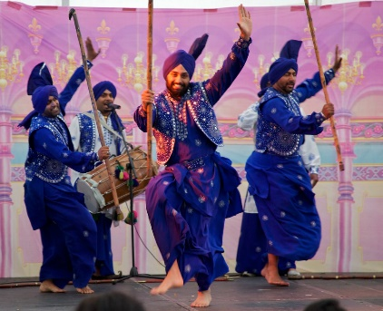Folk dances and plays in India retain significance in rural areas as the expression of the daily work and rituals of village communities.

Sanskrit literature of medieval times describes several forms of group dances such as [Hallisaka](https://en.m.wikipedia.org/w/index.php?title=Hallisaka&action=edit&redlink=1" \o "Hallisaka (page does not exist)), [Rasaka](https://en.m.wikipedia.org/w/index.php?title=Rasaka&action=edit&redlink=1" \o "Rasaka (page does not exist)), [Dand Rasaka](https://en.m.wikipedia.org/w/index.php?title=Dand_Rasaka&action=edit&redlink=1" \o "Dand Rasaka (page does not exist)) and [Charchari](https://en.m.wikipedia.org/wiki/Charchari" \o "Charchari).

The [Natya Shastra](https://en.m.wikipedia.org/wiki/Natya_Shastra" \o "Natya Shastra) includes group dances of women as a preliminary dance performed in prelude to a drama. India has numerous folk dances. Every [state](https://en.m.wikipedia.org/wiki/States_of_India) has its own folk dance forms like [Bihu](https://en.m.wikipedia.org/wiki/Bihu) and [Bagurumba](https://en.m.wikipedia.org/wiki/Bagurumba) in [Assam](https://en.m.wikipedia.org/wiki/Assam), [Garba](https://en.m.wikipedia.org/wiki/Garba_(dance)), , [Neyopa](https://en.m.wikipedia.org/w/index.php?title=Neyopa&action=edit&redlink=1), [Bacha Nagma](https://en.m.wikipedia.org/wiki/Bacha_Nagma) in [Jammu and Kashmir](https://en.m.wikipedia.org/wiki/Jammu_and_Kashmir_(union_territory)), [Jhumair](https://en.m.wikipedia.org/wiki/Jhumair" \o "Jhumair), [Domkach](https://en.m.wikipedia.org/wiki/Domkach" \o "Domkach) in [Jharkhand](https://en.m.wikipedia.org/wiki/Jharkhand), [Bedara Vesha](https://en.m.wikipedia.org/wiki/Bedara_Vesha" \o "Bedara Vesha), [Dollu Kunitha](https://en.m.wikipedia.org/wiki/Dollu_Kunitha" \o "Dollu Kunitha) in [Karnataka](https://en.m.wikipedia.org/wiki/Karnataka), [Thirayattam](https://en.m.wikipedia.org/wiki/Thirayattam) and [Theyyam](https://en.m.wikipedia.org/wiki/Theyyam) in [Kerala](https://en.m.wikipedia.org/wiki/Kerala), [Dalkhai](https://en.m.wikipedia.org/wiki/Dalkhai) in [Odisha](https://en.m.wikipedia.org/wiki/Odisha), [Bhangra](https://en.m.wikipedia.org/wiki/Bhangra_(dance)) & [Giddha](https://en.m.wikipedia.org/wiki/Giddha) in [Punjab](https://en.m.wikipedia.org/wiki/Punjab,_India), [Kalbelia](https://en.m.wikipedia.org/wiki/Kalbelia), [Ghoomar](https://en.m.wikipedia.org/wiki/Ghoomar), [Rasiya](https://en.m.wikipedia.org/wiki/Rasiya) in [Rajasthan](https://en.m.wikipedia.org/wiki/Rajasthan), [Peri 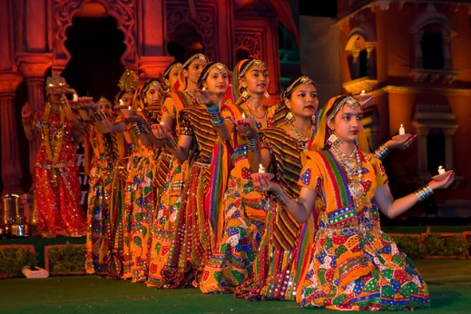ni Dance](https://en.m.wikipedia.org/wiki/Perini_Dance) in [Telangana](https://en.m.wikipedia.org/wiki/Telangana" \o "Telangana), [Chholiya](https://en.m.wikipedia.org/wiki/Chholiya" \o "Chholiya) dance in [Uttarakhand](https://en.m.wikipedia.org/wiki/Uttarakhand" \o "Uttarakhand) and likewise for each state and smaller regions in it. [Lavani](https://en.m.wikipedia.org/wiki/Lavani), and [Lezim](https://en.m.wikipedia.org/wiki/Lezim" \o "Lezim), and Koli dance is most popular dance in [Maharashtra](https://en.m.wikipedia.org/wiki/Maharashtra).

Tribal Dances in India are inspired by the tribal folklore. Each ethnic group has its own distinct combination of myths, legends, tales, proverbs, riddles, ballads, folk songs, folk dance, and folk music.

**Contemporary Dance**

Contemporary dance in India encompasses a wide range of dance activities currently performed in India. It includes choreography for Indian cinema, modern Indian ballet and experiments with existing classical and folk forms of dance by various artists.

Uday Shankar and Shobana Jeyasingh have led modern Indian ballet which combined classical Indian dance and music with Western stage techniques. Their productions have included themes related to Shiva-Parvati, Lanka Dahan, Panchatantra and Ramayana among others.

**Why dance is unique?**

Dancing is special and unique as an art form for several reasons. Firstly, it is a form of expression that combines physical movement with emotion, allowing dancers to convey a wide range of feelings and stories without using words.

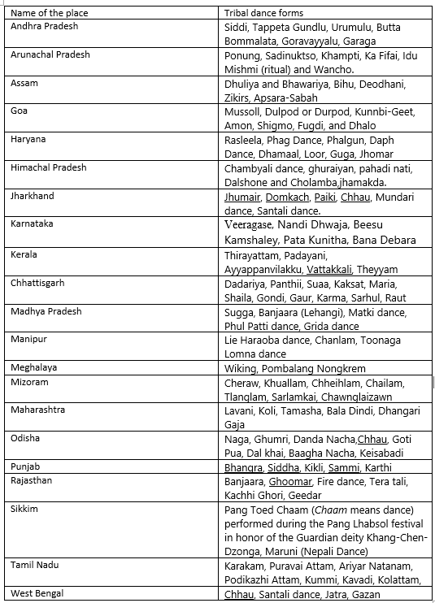

**Tribal dances by territory**

**Dance in Bollywood Film**

Dance in early Hindi films was primarily modeled on classical Indian dance styles such as Kathak, or folk dancers. Modern films often blend this earlier style with Western dance styles, though it is not unusual to see western choreography and adapted classical dance numbers side by side in the same film. Typically, the hero or heroine performs with a troupe of supporting dancers. Many song-and-dance routines in Indian films feature dramatic shifts of location and/or changes of costume between verses of a song. It is popular for a hero and heroine to dance and sing a pas de deux in beautiful natural surroundings or architecturally grand settings, referred to as a "picturisation".Indian films have often used what are now called "item numbers" where a glamorous female figure performs a cameo. The choreography for such item numbers varies depending on the film's genre and situation. The film actress and dancer Helen was famous for her cabaret numbers. Often in movies, the actors don't sing the songs themselves that they dance too, themselves but have another artist sing in the background. For an actor to sing in the song is unlikely but not rare. The dances in Bollywood can range from slow dancing to a more upbeat hip-hop style dance. The dancing itself is a fusion of all dance forms. It could be Indian classical, Indian folk dance, belly dancing, jazz, hip-hop, and everything else you can imagine.

**Dance education**

Since India's independence from colonial rule, numerous schools have opened to further education, training, and socialization through dance classes, or simply a means to exercise and fitness.

Major cities in India now have numerous schools that offer lessons in dances such as Odissi, Bharatanatyam, and these cities host hundreds of shows every year. Dances which were exclusive to one gender, now have participation by both males and females. Many innovations and developments in the modern practice of classical Indian dances, states Anne-Marie Gaston, are of a quasi-religious type.

**Health benefits of dancing**

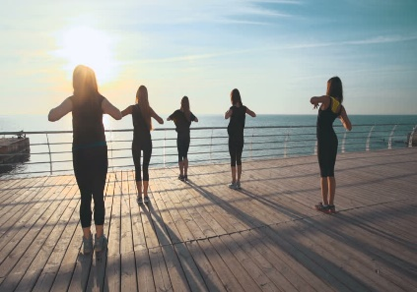Dancing can be a way to stay fit for people of all ages, shapes and sizes. It has a wide range of physical and mental benefits including:

* improved condition of your heart and lungs
* increased muscular strength, endurance and motor fitness
* increased aerobic fitness
* improved muscle tone and strength
* weight management
* stronger bones and reduced risk of osteoporosis
* better coordination, agility and flexibility
* improved balance and spatial awareness
* increased physical confidence
* improved mental functioning
* improved general and psychological wellbeing
* Greater self-confidence and self-esteem better social skills.

Dancing can be a way to stay fit for people of all ages, shapes and sizes. Dancing can improve your muscle tone, strength, endurance and fitness. Dancing is a great way to meet new friends. See your doctor for a check-up if you have a medical condition, are overweight, are over 40 years of age or are unfit.

## Disadvantages of Being a Dancer

Dancers are athletes. Like those who play professional sports, professional dancers usually begin training at a young age. Training is intense, requiring long hours that demand both physical and mental stamina. There is always the risk of injury and, in some cases, those injuries can end a career. Even without significant injury, dancing can take a tremendous toll on the body. Dancers may have to shift their focus and change career goals as they get older.

As the jobs website [indeed](https://www.indeed.com/career-advice/pay-salary/how-much-do-broadway-dancers-make) points out, performing in a Broadway show is a dream come true for many dancers. With the experience and skills gained from being part of a Broadway show, dancers and their understudies may go on to busy, well-earning careers. Competition for jobs is intense – there can be literally thousands of hopefuls when there are dancer auditions for a major show.

Even if you're not auditioning for a major show, dancers typically face a great deal of competition from other talented and trained individuals. Arts programs frequently face funding challenges and positions for dancers, choreographers, instructors and therapists may suffer. For most communities, there is a limit to how many dance professionals it can support.

## Uses of dance

### Physical health and fitness

[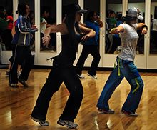](https://en.wikipedia.org/wiki/File:Ellsworth_Zumba_demo.JPG)Dancing can be a way to stay fit for people of all ages, shapes and sizes, having a wide range of physical, and mental benefits including improved condition of the heart and lungs, increased muscular strength, endurance and motor fitness, increased aerobic fitness, improved muscle tone and strength, weight management, stronger bones and reduced risk of osteoporosis, better coordination, agility and flexibility, improved balance and spatial awareness, increased physical confidence, improved mental functioning, improved general and psychological well-being, greater self-confidence and self-esteem, and better social skills. Most forms of dance may be considered aerobic exercise and as such can also reduce the risk of cardiovascular disease, help weight control, stress reduction, and bring about other benefits commonly associated with physical fitness. In addition, studies have demonstrated a considerable correlation between dancing and psychological well-being. A large amount of governmental, health and educational information is available extolling the benefits of dance for health.

**Benefits of Cultural dance** Physical activity has many physical and mental health outcomes; however, physical inactivity continues to be common. Dance, specifically cultural dance, is a type of physical activity that may appeal to some who are not otherwise active and can be a form of activity that is more acceptable than others in certain cultures.

A 2008 report by Professor Tim Watson and Dr. Andrew Garrett of the University of Hertfordshire compared members of the Royal Ballet with a squad of British national and international swimmers. The dancers scored higher than the swimmers in seven out of ten areas of fitness.

For those with hypercholesterolemia, dancing - in conjunction with diet and medication such as statins - can provide positive health benefits. As an aerobic exercise abridged levels of total blood cholesterol, especially in LDL cholesterol, acknowledged as bad and helps boost levels of HDL cholesterol. Dancing in general increases muscle strength and flexibility, which in turn, improves overall range of motion. Dance also increases core strength which can improve balance, coordination, and posture (which can, in turn, reduce mechanical back pain).

Dance therapy is suggested for patients today as a treatment for emotional and therapeutic support, as dance allows individuals to connect with their inner-self.